Spring common interview questions

<bean id="bean1" class ="Employee" >
<bean id="bean2" class ="Employee" >
if tow beans og same type with diff id’s so how many objects will create

Yes. Spring will create two instances in this scenario. Spring container creates a singleton instance per bean definition. EX:

public class Test {

@SuppressWarnings("resource")
public static void main(String[] args) {

ApplicationContext ac = new ClassPathXmlApplicationContext("ws.xml");
TestBean teatBean = (TestBean) ac.getBean(TestBean.class);
TestBean myBean1 = (TestBean) ac.getBean(TestBean.class);
System.out.println("a : " + teatBean.test + " : "
+ teatBean.getName());
teatBean.setName("a TEST BEAN 1");
System.out.println("uPdate : " + teatBean.test + " : "
+ teatBean.getName());

System.out.println("a1 : " + myBean1.test + " : " + myBean1.getName());
myBean1.setName(" a1 TEST BEAN 10");
System.out.println("a1 update : " + teatBean.test + " : "
+ myBean1.getName());

}

}

diff between singleton design pattern and singleton bean in spring

For a given Id, Spring container maintain only one shared an instance of singleton bean. In our example

Spring Ioc container created 2 instances of the same class based on bean definition and binds them with ids.
Spring bean definition work as a key-value pair, the key is mapped to bean id and value mapped to the bean instance.
Each key reference returns the same bean instance (refer to “bean1” always return bean instance associated with id “bean1”).

Summary
Spring Singleton is very different from Singleton pattern. Spring guarantees to create only one bean instance for given bean id definition per container.Singleton pattern ensures that one and only one instance is created per ClassLoader.

1. Singleton Scope vs Singleton Pattern
Singleton scope in Spring is not same as singleton pattern. Some of the main differences between these 2 are

Singleton pattern ensures one instance of a particular class of per class loader.
Spring Singleton is “per container per bean”.
If you pay close attention, these are entirely different design in terms of how they define singleton.

Q) Accepting / returning XML/JSON request and response - Spring MVC

@RequestMapping(value = "/getxmljson", method = RequestMethod.POST,produces={"application/json","application/xml"},consumes={"application/json", "application/xml"})

public @ResponseBody Student processXMLJsonRequest(@RequestBody Student student)
throws Exception {
System.out.println("*************Inside Controller");
return student;

}

Define bean value object as below –

@XmlRootElement(name = "student")
@XmlType(propOrder = {"id", "name", "graduationTime", "courses"})
@JsonPropertyOrder({"id", "name", "graduationTime", "courses"})
public class Student implements Serializable {
private static final long serialVersionUID = 1L;

private int id;
private String name;
private String graduationTime;
private ArrayList<Course> courses = new ArrayList<Course>();

@XmlElement
public int getId() { return id; }
@XmlElement
public String getName() { return name; }
@XmlElement
public String getGraduationTime() { return graduationTime; }
@XmlElement
public ArrayList<Course> getCourses() { return courses; }

public void setId(int value) { this.id = value; }
public void setName(String value) { this.name = value; }
public void setGraduationTime(String value) { this.graduationTime = value; }
public void setCourses(ArrayList<Course> value) { this.courses = value; }

@JsonIgnore
public String toString() {
return this.name + " - "
+ graduationTime == null? "Unknown" : graduationTime.toString();
}

public Student() {}
public Student(int id, String name, String graduationTime) {
this.id = id;
this.name = name;
this.graduationTime = graduationTime;
}
}
3) Use ContentNegotiatingViewResolver instead of RequestMappingHandlerAdapter

<bean class="org.springframework.web.servlet.view.ContentNegotiatingViewResolver">
<property name="defaultViews">
<list>
<bean class="org.springframework.web.servlet.view.json.MappingJackson2JsonView"/>
</list>
</property>
</bean>

<beans:bean class="org.springframework.web.servlet.mvc.method.annotation.RequestMappingHandlerAdapter">
<beans:property name="messageConverters">
<beans:list>
<beans:ref bean="jsonMessageConverter"/>
<beans:ref bean="xmlMessageConverter"/>
</beans:list>
</beans:property>
</beans:bean>
<!-- Configure bean to convert JSON to POJO and vice versa --> <beans:bean id="jsonMessageConverter" class="org.springframework.http.converter.json.MappingJackson2HttpMessageConverter">
</beans:bean>

<beans:bean id="xmlMessageConverter" class="org.springframework.http.converter.xml.Jaxb2RootElementHttpMessageConverter">
</beans:bean>

3) Step 3: Use Accepts and Content-Type HTTP headers
Hitting your controller with the correct HTTP header values will force ContentNegotiatingViewResolver to marshal and unmarshal data automatically using the appropriate data representations.
If you want to exchange data in JSON format, set both headers to application/json. If you want XML instead, set both to application/xml.
If you do not want to use HTTP headers (which ideally you should), you can simply add .json or .xml to the URL and ContentNegotiatingViewResolver will do the rest.

Q) what is use of ‘spring.boot.starter’ .
Q) what is use of ‘spring.boot.starter.parent’ .
Q) how @EnableAutoConfiguration works .

Spring Security Form Login

- Add dependency -
<dependency>
<groupId>org.springframework.boot</groupId>
<artifactId>spring-boot-starter-security</artifactId> <version>2.3.3.RELEASE</version>
</dependency>

- Add spring configuration -
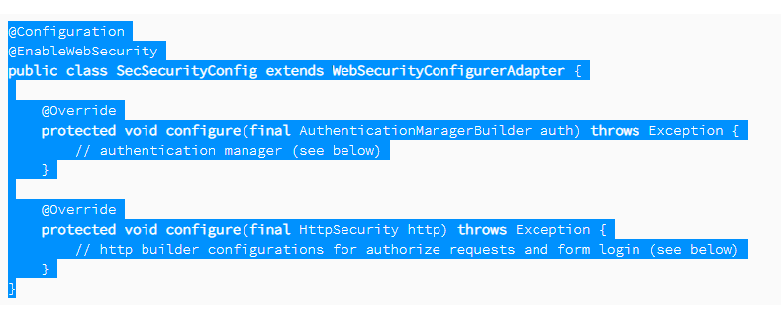

Add Spring Security to the Web Application
To use the above-defined Spring Security configuration, we need to attach it to the web application.
We'll use the WebApplicationInitializer, so we don't need to provide any web.xml:

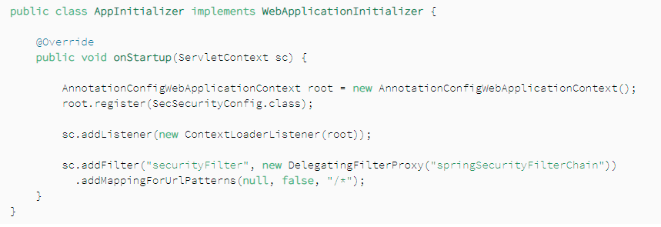
Or below type
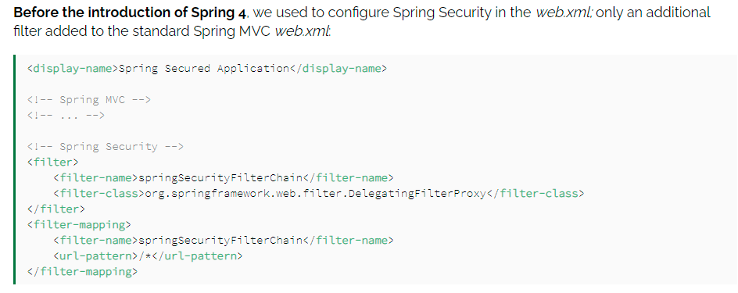
<web-app id = "WebApp_ID" version = "2.4"
xmlns = "http://java.sun.com/xml/ns/j2ee"
xmlns:xsi = "http://www.w3.org/2001/XMLSchema-instance"
xsi:schemaLocation = "http://java.sun.com/xml/ns/j2ee
http://java.sun.com/xml/ns/j2ee/web-app_2_4.xsd">

<display-name>Spring MVC Application</display-name>

<servlet>
<servlet-name>HelloWeb</servlet-name>
<servlet-class>
org.springframework.web.servlet.DispatcherServlet
</servlet-class>
<load-on-startup>1</load-on-startup>
</servlet>

<servlet-mapping>
<servlet-name>HelloWeb</servlet-name>
<url-pattern>*.jsp</url-pattern>
</servlet-mapping>

</web-app>
If you do not want to go with default filename as [servlet-name]-servlet.xml and default location as WebContent/WEB-INF, you can customize this file name and location by adding the servlet listener ContextLoaderListener in your web.xml file as follows −
<web-app...>

<!-------- DispatcherServlet definition goes here----->
....
<context-param>
<param-name>contextConfigLocation</param-name>
<param-value>/WEB-INF/HelloWeb-servlet.xml</param-value>
</context-param>

<listener>
<listener-class>
org.springframework.web.context.ContextLoaderListener
</listener-class>
</listener>

</web-app>

Let us now understand different @Transactional attributes.

@Transactional (isolation=Isolation.READ_COMMITTED)

The default is Isolation.DEFAULT
Most of the times, you will use default unless and until you have specific requirements.
Informs the transaction (tx) manager that the following isolation level should be used for the current tx. Should be set at the point from where the tx starts because we cannot change the isolation level after starting a tx.
DEFAULT: Use the default isolation level of the underlying database.

READ_COMMITTED: A constant indicating that dirty reads are prevented; non-repeatable reads and phantom reads can occur.

READ_UNCOMMITTED: This isolation level states that a transaction may read data that is still uncommitted by other transactions.

REPEATABLE_READ: A constant indicating that dirty reads and non-repeatable reads are prevented; phantom reads can occur.

SERIALIZABLE: A constant indicating that dirty reads, non-repeatable reads, and phantom reads are prevented.

What do these Jargons dirty reads, phantom reads, or repeatable reads mean?

Dirty Reads: Transaction "A" writes a record. Meanwhile, Transaction "B" reads that same record before Transaction A commits. Later, Transaction A decides to rollback and now we have changes in Transaction B that are inconsistent. This is a dirty read. Transaction B was running in READ_UNCOMMITTED isolation level so it was able to read Transaction A changes before a commit occurred.
Non-Repeatable Reads: Transaction "A" reads some record. Then Transaction "B" writes that same record and commits. Later Transaction A reads that same record again and may get different values because Transaction B made changes to that record and committed. This is a non-repeatable read.
Phantom Reads: Transaction "A" reads a range of records. Meanwhile, Transaction "B" inserts a new record in the same range that Transaction A initially fetched and commits. Later Transaction A reads the same range again and will also get the record that Transaction B just inserted. This is a phantom read: a transaction fetched a range of records multiple times from the database and obtained different result sets (containing phantom records).
@Transactional(timeout=60)

Defaults to the default timeout of the underlying transaction system.

Informs the tx manager about the time duration to wait for an idle tx before a decision is taken to rollback non-responsive transactions.

@Transactional(propagation=Propagation.REQUIRED)

If not specified, the default propagational behavior is REQUIRED.

Other options are REQUIRES_NEW , MANDATORY , SUPPORTS , NOT_SUPPORTED , NEVER , and NESTED .

REQUIRED

Indicates that the target method cannot run without an active tx. If atxhas already been started before the invocation of this method, then it will continue in the same tx or a newtxwould begin soon as this method is called.
REQUIRES_NEW

Indicates that a newtxhas to start every time the target method is called. If already atxis going on, it will be suspended before starting a new one.
MANDATORY

Indicates that the target method requires an active tx to be running. If atxis not going on, it will fail by throwing an exception.
SUPPORTS

Indicates that the target method can execute irrespective of atx. If atxis running, it will participate in the same tx. If executed without a tx it will still execute if no errors.
Methods which fetch data are the best candidates for this option.
NOT_SUPPORTED

Indicates that the target method doesn’t require the transaction context to be propagated.
Mostly those methods which run in a transaction but perform in-memory operations are the best candidates for this option.
NEVER

Indicates that the target method will raise an exception if executed in a transactional process.
This option is mostly not used in projects.
@Transactional (rollbackFor=Exception.class)

Default is rollbackFor=RunTimeException.class
In Spring, all API classes throw RuntimeException, which means if any method fails, the container will always rollback the ongoing transaction.
The problem is only with checked exceptions. So this option can be used to declaratively rollback a transaction if Checked Exception occurs.
@Transactional (noRollbackFor=IllegalStateException.class)

Indicates that a rollback should not be issued if the target method raises this exception.
Now the last but most important step in transaction management is the placement of @Transactional annotation. Most of the times, there is a confusion where should the annotation be placed: at Service layer or DAO layer?

@Transactional: Service or DAO Layer?

The Service is the best place for putting @Transactional, service layer should hold the detail-level use case behavior for a user interaction that would logically go in a transaction.

HTTP response status codes
Informational responses ( 100 – 199 )
Successful responses ( 200 – 299 )
Redirects ( 300 – 399 )
Client errors ( 400 – 499 )
Server errors ( 500 – 599 )
Information responses
100 Continue
This interim response indicates that everything so far is OK and that the client should continue the request, or ignore the response if the request is already finished.

101 Switching Protocol
This code is sent in response to an Upgrade request header from the client, and indicates the protocol the server is switching to.

102 Processing (WebDAV)
This code indicates that the server has received and is processing the request, but no response is available yet.

103 Early Hints
This status code is primarily intended to be used with the Link header, letting the user agent start preloading resources while the server prepares a response.

Successful responses
200 OK
The request has succeeded. The meaning of the success depends on the HTTP method:

GET: The resource has been fetched and is transmitted in the message body.
HEAD: The representation headers are included in the response without any message body.
PUT or POST: The resource describing the result of the action is transmitted in the message body.
TRACE: The message body contains the request message as received by the server.
201 Created
The request has succeeded and a new resource has been created as a result. This is typically the response sent after POST requests, or some PUT requests.

202 Accepted
The request has been received but not yet acted upon. It is noncommittal, since there is no way in HTTP to later send an asynchronous response indicating the outcome of the request. It is intended for cases where another process or server handles the request, or for batch processing.

203 Non-Authoritative Information
This response code means the returned meta-information is not exactly the same as is available from the origin server, but is collected from a local or a third-party copy. This is mostly used for mirrors or backups of another resource. Except for that specific case, the "200 OK" response is preferred to this status.

204 No Content
There is no content to send for this request, but the headers may be useful. The user-agent may update its cached headers for this resource with the new ones.

205 Reset Content
Tells the user-agent to reset the document which sent this request.

206 Partial Content
This response code is used when the Range header is sent from the client to request only part of a resource.

207 Multi-Status (WebDAV)
Conveys information about multiple resources, for situations where multiple status codes might be appropriate.

208 Already Reported (WebDAV)
Used inside a <dav:propstat> response element to avoid repeatedly enumerating the internal members of multiple bindings to the same collection.

226 IM Used (HTTP Delta encoding)
The server has fulfilled a GET request for the resource, and the response is a representation of the result of one or more instance-manipulations applied to the current instance.

Redirection messages
300 Multiple Choice
The request has more than one possible response. The user-agent or user should choose one of them. (There is no standardized way of choosing one of the responses, but HTML links to the possibilities are recommended so the user can pick.)

301 Moved Permanently
The URL of the requested resource has been changed permanently. The new URL is given in the response.

302 Found
This response code means that the URI of requested resource has been changed temporarily. Further changes in the URI might be made in the future. Therefore, this same URI should be used by the client in future requests.

303 See Other
The server sent this response to direct the client to get the requested resource at another URI with a GET request.

304 Not Modified
This is used for caching purposes. It tells the client that the response has not been modified, so the client can continue to use the same cached version of the response.

305 Use Proxy
Defined in a previous version of the HTTP specification to indicate that a requested response must be accessed by a proxy. It has been deprecated due to security concerns regarding in-band configuration of a proxy.

306 unused
This response code is no longer used; it is just reserved. It was used in a previous version of the HTTP/1.1 specification.

307 Temporary Redirect
The server sends this response to direct the client to get the requested resource at another URI with same method that was used in the prior request. This has the same semantics as the 302 Found HTTP response code, with the exception that the user agent must not change the HTTP method used: If a POST was used in the first request, a POST must be used in the second request.

308 Permanent Redirect
This means that the resource is now permanently located at another URI, specified by the Location: HTTP Response header. This has the same semantics as the 301 Moved Permanently HTTP response code, with the exception that the user agent must not change the HTTP method used: If a POST was used in the first request, a POST must be used in the second request.

Client error responses
400 Bad Request
The server could not understand the request due to invalid syntax.

401 Unauthorized
Although the HTTP standard specifies "unauthorized", semantically this response means "unauthenticated". That is, the client must authenticate itself to get the requested response.

402 Payment Required
This response code is reserved for future use. The initial aim for creating this code was using it for digital payment systems, however this status code is used very rarely and no standard convention exists.

403 Forbidden
The client does not have access rights to the content; that is, it is unauthorized, so the server is refusing to give the requested resource. Unlike 401, the client's identity is known to the server.

404 Not Found
The server can not find the requested resource. In the browser, this means the URL is not recognized. In an API, this can also mean that the endpoint is valid but the resource itself does not exist. Servers may also send this response instead of 403 to hide the existence of a resource from an unauthorized client. This response code is probably the most famous one due to its frequent occurrence on the web.

405 Method Not Allowed
The request method is known by the server but is not supported by the target resource. For example, an API may forbid DELETE-ing a resource.

406 Not Acceptable
This response is sent when the web server, after performing server-driven content negotiation, doesn't find any content that conforms to the criteria given by the user agent.

407 Proxy Authentication Required
This is similar to 401 but authentication is needed to be done by a proxy.

408 Request Timeout
This response is sent on an idle connection by some servers, even without any previous request by the client. It means that the server would like to shut down this unused connection. This response is used much more since some browsers, like Chrome, Firefox 27+, or IE9, use HTTP pre-connection mechanisms to speed up surfing. Also note that some servers merely shut down the connection without sending this message.

409 Conflict
This response is sent when a request conflicts with the current state of the server.

410 Gone
This response is sent when the requested content has been permanently deleted from server, with no forwarding address. Clients are expected to remove their caches and links to the resource. The HTTP specification intends this status code to be used for "limited-time, promotional services". APIs should not feel compelled to indicate resources that have been deleted with this status code.

411 Length Required
Server rejected the request because the Content-Length header field is not defined and the server requires it.

412 Precondition Failed
The client has indicated preconditions in its headers which the server does not meet.

413 Payload Too Large
Request entity is larger than limits defined by server; the server might close the connection or return an Retry-After header field.

414 URI Too Long
The URI requested by the client is longer than the server is willing to interpret.

415 Unsupported Media Type
The media format of the requested data is not supported by the server, so the server is rejecting the request.

416 Range Not Satisfiable
The range specified by the Range header field in the request can't be fulfilled; it's possible that the range is outside the size of the target URI's data.

417 Expectation Failed
This response code means the expectation indicated by the Expect request header field can't be met by the server.

418 I'm a teapot
The server refuses the attempt to brew coffee with a teapot.

421 Misdirected Request
The request was directed at a server that is not able to produce a response. This can be sent by a server that is not configured to produce responses for the combination of scheme and authority that are included in the request URI.

422 Unprocessable Entity (WebDAV)
The request was well-formed but was unable to be followed due to semantic errors.

423 Locked (WebDAV)
The resource that is being accessed is locked.

424 Failed Dependency (WebDAV)
The request failed due to failure of a previous request.

425 Too Early
Indicates that the server is unwilling to risk processing a request that might be replayed.

426 Upgrade Required
The server refuses to perform the request using the current protocol but might be willing to do so after the client upgrades to a different protocol. The server sends an Upgrade header in a 426 response to indicate the required protocol(s).

428 Precondition Required
The origin server requires the request to be conditional. This response is intended to prevent the 'lost update' problem, where a client GETs a resource's state, modifies it, and PUTs it back to the server, when meanwhile a third party has modified the state on the server, leading to a conflict.

429 Too Many Requests
The user has sent too many requests in a given amount of time ("rate limiting").

431 Request Header Fields Too Large
The server is unwilling to process the request because its header fields are too large. The request may be resubmitted after reducing the size of the request header fields.

451 Unavailable For Legal Reasons
The user-agent requested a resource that cannot legally be provided, such as a web page censored by a government.

Server error responses
500 Internal Server Error
The server has encountered a situation it doesn't know how to handle.

501 Not Implemented
The request method is not supported by the server and cannot be handled. The only methods that servers are required to support (and therefore that must not return this code) are GET and HEAD.

502 Bad Gateway
This error response means that the server, while working as a gateway to get a response needed to handle the request, got an invalid response.

503 Service Unavailable
The server is not ready to handle the request. Common causes are a server that is down for maintenance or that is overloaded. Note that together with this response, a user-friendly page explaining the problem should be sent. This response should be used for temporary conditions and the Retry-After: HTTP header should, if possible, contain the estimated time before the recovery of the service. The webmaster must also take care about the caching-related headers that are sent along with this response, as these temporary condition responses should usually not be cached.

504 Gateway Timeout
This error response is given when the server is acting as a gateway and cannot get a response in time.

505 HTTP Version Not Supported
The HTTP version used in the request is not supported by the server.

506 Variant Also Negotiates
The server has an internal configuration error: the chosen variant resource is configured to engage in transparent content negotiation itself, and is therefore not a proper end point in the negotiation process.

507 Insufficient Storage (WebDAV)
The method could not be performed on the resource because the server is unable to store the representation needed to successfully complete the request.

508 Loop Detected (WebDAV)
The server detected an infinite loop while processing the request.

510 Not Extended
Further extensions to the request are required for the server to fulfill it.

511 Network Authentication Required
The 511 status code indicates that the client needs to authenticate to gain network access.

RestTemplate methods : ---
https://springframework.guru/using-resttemplate-in-spring/

Spring

What is Spring Framework?
- Spring is a powerful open source, loosely coupled, light weight, java based application framework meant for reducing the complexity of developing enterprise level applications. This framework is also called as the "framework of frameworks" as spring provides support to various other important frameworks like JSF, Hibernate, Structs, EJB etc.
- There are around 20 modules which are generalized into the following types:
  - Core Container
  - Data Access/Integration
  - Web
  - AOP (Aspect Oriented Programming)
  - Instrumentation
  - Messaging
  - Test
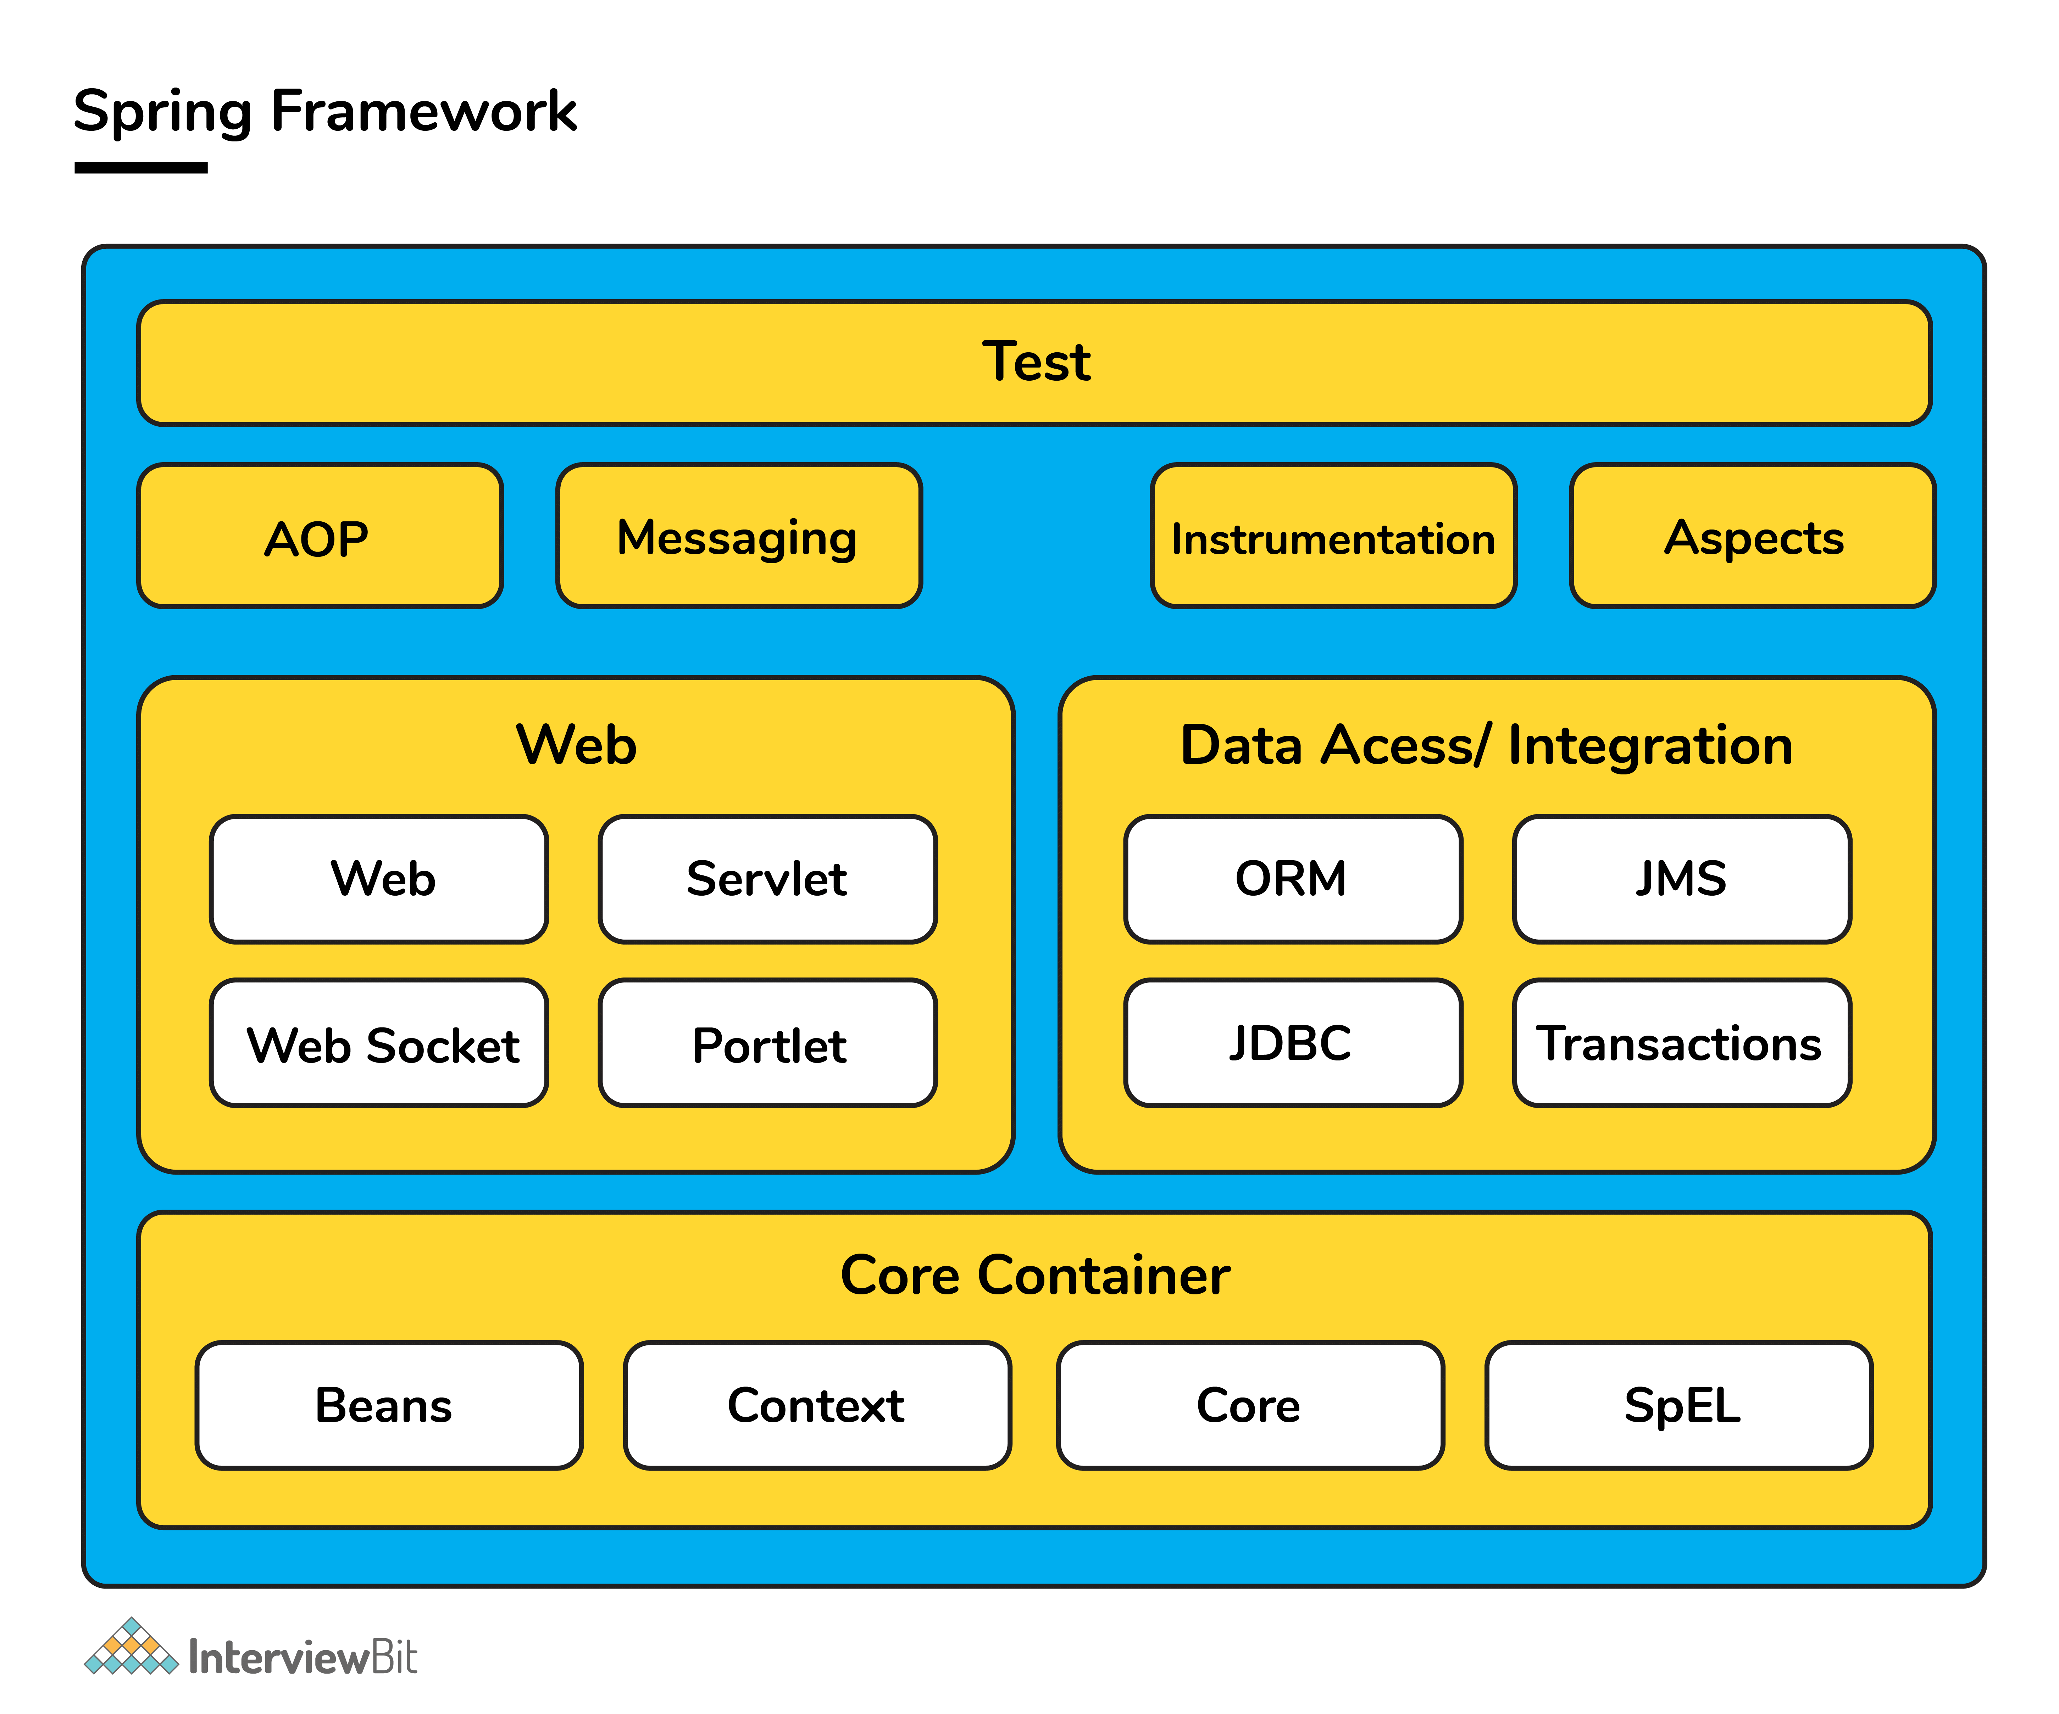

Spring handles all the infrastructure related aspects which lets the programmer to focus mostly on application development.

What are the features of Spring Framework?
- Spring framework follows layered architecture pattern that helps in the necessary components selection along with providing a robust and cohesive framework for J2EE applications development.
- The AOP (Aspect Oriented Programming) part of Spring supports unified development by ensuring separation of application's business logic from other system services.
- Spring provides highly configurable MVC web application framework which has the ability to switch to other frameworks easily.
- Provides provision of creation and management of the configurations and defining the lifecycle of application objects.
- Spring has a special design principle which is known as IoC (Inversion of Control) that supports objects to give their dependencies rather than looking for creating dependent objects.
- Spring is a lightweight, java based, loosely coupled framework.
- Spring provides generic abstraction layer for transaction management that is also very useful for container-less environments.
- Spring provides a convenient API to translate technology-specific exceptions (thrown by JDBC, Hibernate or other frameworks) into consistent, unchecked exceptions. This introduces abstraction and greatly simplifies exception handling.

Spring, Spring Core, Spring IoC Interview Questions

1. What is a Spring configuration file?
Spring configuration file is basically a XML file which mainly contains the classes information and describes how those classes are configured and linked to each other. The XML configuration files are verbose and more clean.

2. What do you mean by IoC (Inversion of Control) Container?
Spring container forms the core of the Spring Framework. The Spring container uses Dependency Injection (DI) for managing the application components by creating objects, wiring them together along with configuring and managing their overall life cycles. The instructions for the spring container to do the tasks can be provided either by XML configuration, Java annotations or Java code.
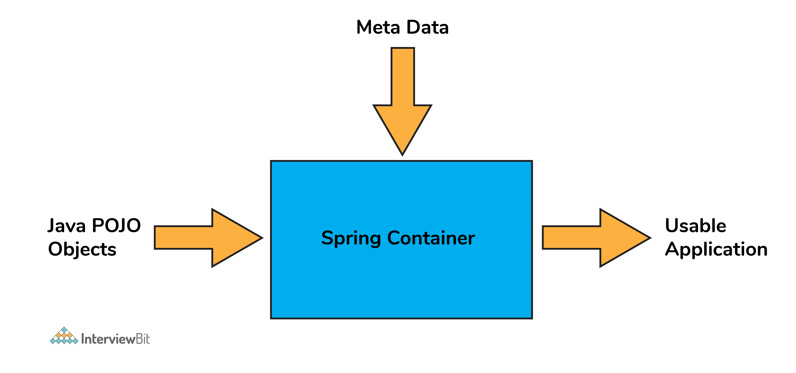

3. What do you understand by Dependency Injection?
The main idea in Dependency Injection is that you don't have to create your objects but you just have to describe how they should be created.
- The components and services need not be connected by us in the code directly. We have to describe which services are needed by which components in the configuration file. The IoC container present in Spring will wire them up together.
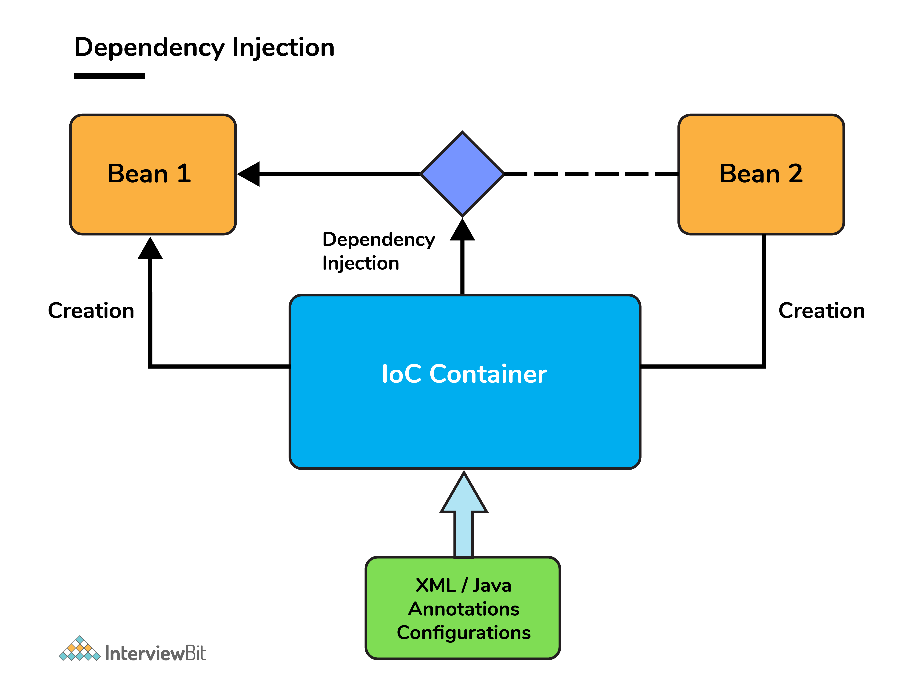
- In Java, the 2 major ways of achieving dependency injection are:
  - Constructor injection: Here, IoC container invokes the class constructor with a number of arguments where each argument represents a dependency on the other class.
  - Setter injection: Here, the spring container calls the setter methods on the beans after invoking a no-argument static factory method or default constructor to instantiate the bean.

4. Explain the difference between constructor and setter injection?
- In constructor injection, partial injection is not allowed whereas it is allowed in setter injection.
- The constructor injection doesn’t override the setter property whereas the same is not true for setter injection.
- Constructor injection creates a new instance if any modification is done. Creation of new instance is not possible in setter injection.
- In case the bean has many properties, then constructor injection is preferred. If it has few properties, then setter injection is preferred.

6. How is the configuration meta data provided to the spring container?
- There are 3 ways of providing the configuration meta data. They are as follows:
  - XML-Based configuration: The bean configurations and its dependencies are specified in XML configuration files. This starts with a bean tag as shown below:
  - <bean id="interviewBitBean" class="org.intervuewBit.firstSpring.InterviewBitBean">
  - <property name="name" value="InterviewBit"></property>
  - </bean>
  - Annotation-Based configuration: Instead of XML approach, the beans can be configured into the component class itself by using annotations on the relevant class, method, or field declaration.
    - Annotation wiring is not active in the Spring container by default. This has to be enabled in the Spring XML configuration file as shown below
    - <beans>
    - <context:annotation-config/>
    - <!-- bean definitions go here -->
    - </beans>
  - Java-based configuration: Spring Framework introduced key features as part of new Java-configuration support. This makes use of the @Configuration annotated classes and @Bean annotated methods. Note that:
    - @Bean annotation has the same role of the <bean/> element.
    - Classes annotated with @Configuration allows to define inter-bean dependencies by simply calling other @Bean methods in the same class.

7. What are the bean scopes available in Spring?
The Spring Framework has five scope supports. They are:
- Singleton: The scope of bean definition while using this would be single instance per IoC container.
- Prototype: Here, the scope for a single bean definition can be any number of object instances.
- Request: The scope of bean definition is an HTTP-request.
- Session: Here, the scope of bean definition is HTTP-session.
- Global-session: The scope of bean definition here is an Global HTTP-session.
Note: The last three scopes are available only if the users use web-aware ApplicationContext containers.

8. Explain Bean life cycle in Spring Bean Factory Container.
Bean life cycle is as follows:
- The IoC container instantiates the bean from the bean’s definition in the XML file.
- Spring then populates all of the properties using the dependency injection as specified in the bean definition.
- The bean factory container calls setBeanName() which takes the bean ID and the corresponding bean has to implement BeanNameAware interface.
- The factory then calls setBeanFactory() by passing an instance of itself (if BeanFactoryAware interface is implemented in the bean).
- If BeanPostProcessors is associated with a bean, then the preProcessBeforeInitialization() methods are invoked.
- If an init-method is specified, then it will be called.
- Lastly, postProcessAfterInitialization() methods will be called if there are any BeanPostProcessors associated with the bean needs to be run post the creation.

10. What is auto wiring and name the different modes of it?
The IoC container autowires relationships between the application beans. Spring lets collaborators to resolve which bean has to be wired automatically by inspecting the contents of the BeanFactory. Different modes of this process are:
- no: This means no autowiring and is the default setting. Explicit bean reference should be used for wiring.
- byName: The bean dependency is injected according to name of the bean. This matches and wires its properties with the beans defined by the same names as per the configuration.
- byType: This injects the bean dependency based on type.
- constructor: Here, it injects the bean dependency by calling the constructor of the class. It has a large number of parameters.
- autodetect: First the container tries to wire using autowire by constructor, if it isnt possible then it tries to autowire by byType.

11. What are the limitations of auto wiring?
- Overriding possibility: Dependencies are specified using <constructor-arg> and <property> settings which overrides autowiring.
- Data types restriction: Primitive data types, Strings and Classes can’t be autowired.

Spring Boot

1. What do you understand by the term 'Spring Boot'?
- Spring Boot is a open source, java based framework which provides support for Rapid Application Development and gives a platform for developing stand-alone and production ready spring applications with needs for very few configurations.

2. Explain the advantages of using Spring Boot for application development.
- Spring Boot helps to create stand-alone applications which can be started using java.jar (Doesn't require to configure WAR files).
- Spring Boot also offers pinpointed 'started' POMs to Maven configuration.
- Has provision to embed Undertow, Tomcat, Jetty or other web servers directly.
- Auto-Configuration: Provides a way to automatically configure an application based on the dependencies present on the classpath.
- Spring Boot was developed with the intention of lessening the lines of code.
- It offers production ready support like monitoring and apps developed using spring boot is easier to launch.

3. Differentiate between Spring and Spring Boot.
- The Spring Framework provides multiple features like dependency injection, data binding, aspect-oriented programming (AOP), data access, and many more that helps easier development of web applications whereas Spring Boot helps in easier usage of the Spring Framework by simplifying or managing various loosely coupled blocks of Spring which are tedious and have a potential of becoming messy.
- Spring boot simplifies commonly used spring dependencies and runs applications straight from a command line. It also doesn’t require an application container and it helps in monitoring several components and configures them externally.

4. What are the features of Spring Boot?
- Spring Boot CLI – This allows you to Groovy / Maven for writing Spring boot application and avoids boilerplate code.
- Starter Dependency – With the help of this feature, Spring Boot aggregates common dependencies together and eventually improves productivity and reduces the burden on
- Spring Initializer – This is a web application that helps a developer in creating an internal project structure. The developer does not have to manually set up the structure of the project while making use of this feature.
- Auto-Configuration – This helps in loading the default configurations according to the project you are working on. In this way, unnecessary WAR files can be avoided.
- Spring Actuator – Spring boot uses actuator to provide "Management EndPoints" which helps the developer in going through the Application Internals, Metrics etc.
- Logging and Security – This ensures that all the applications made using Spring Boot are properly secured without any hassle.

5. What does @SpringBootApplication annotation do internally?
- As per the Spring Boot documentation, the @SpringBootApplication annotation is one point replacement for using @Configuration, @EnableAutoConfiguration and @ComponentScan annotations alongside their default attributes.
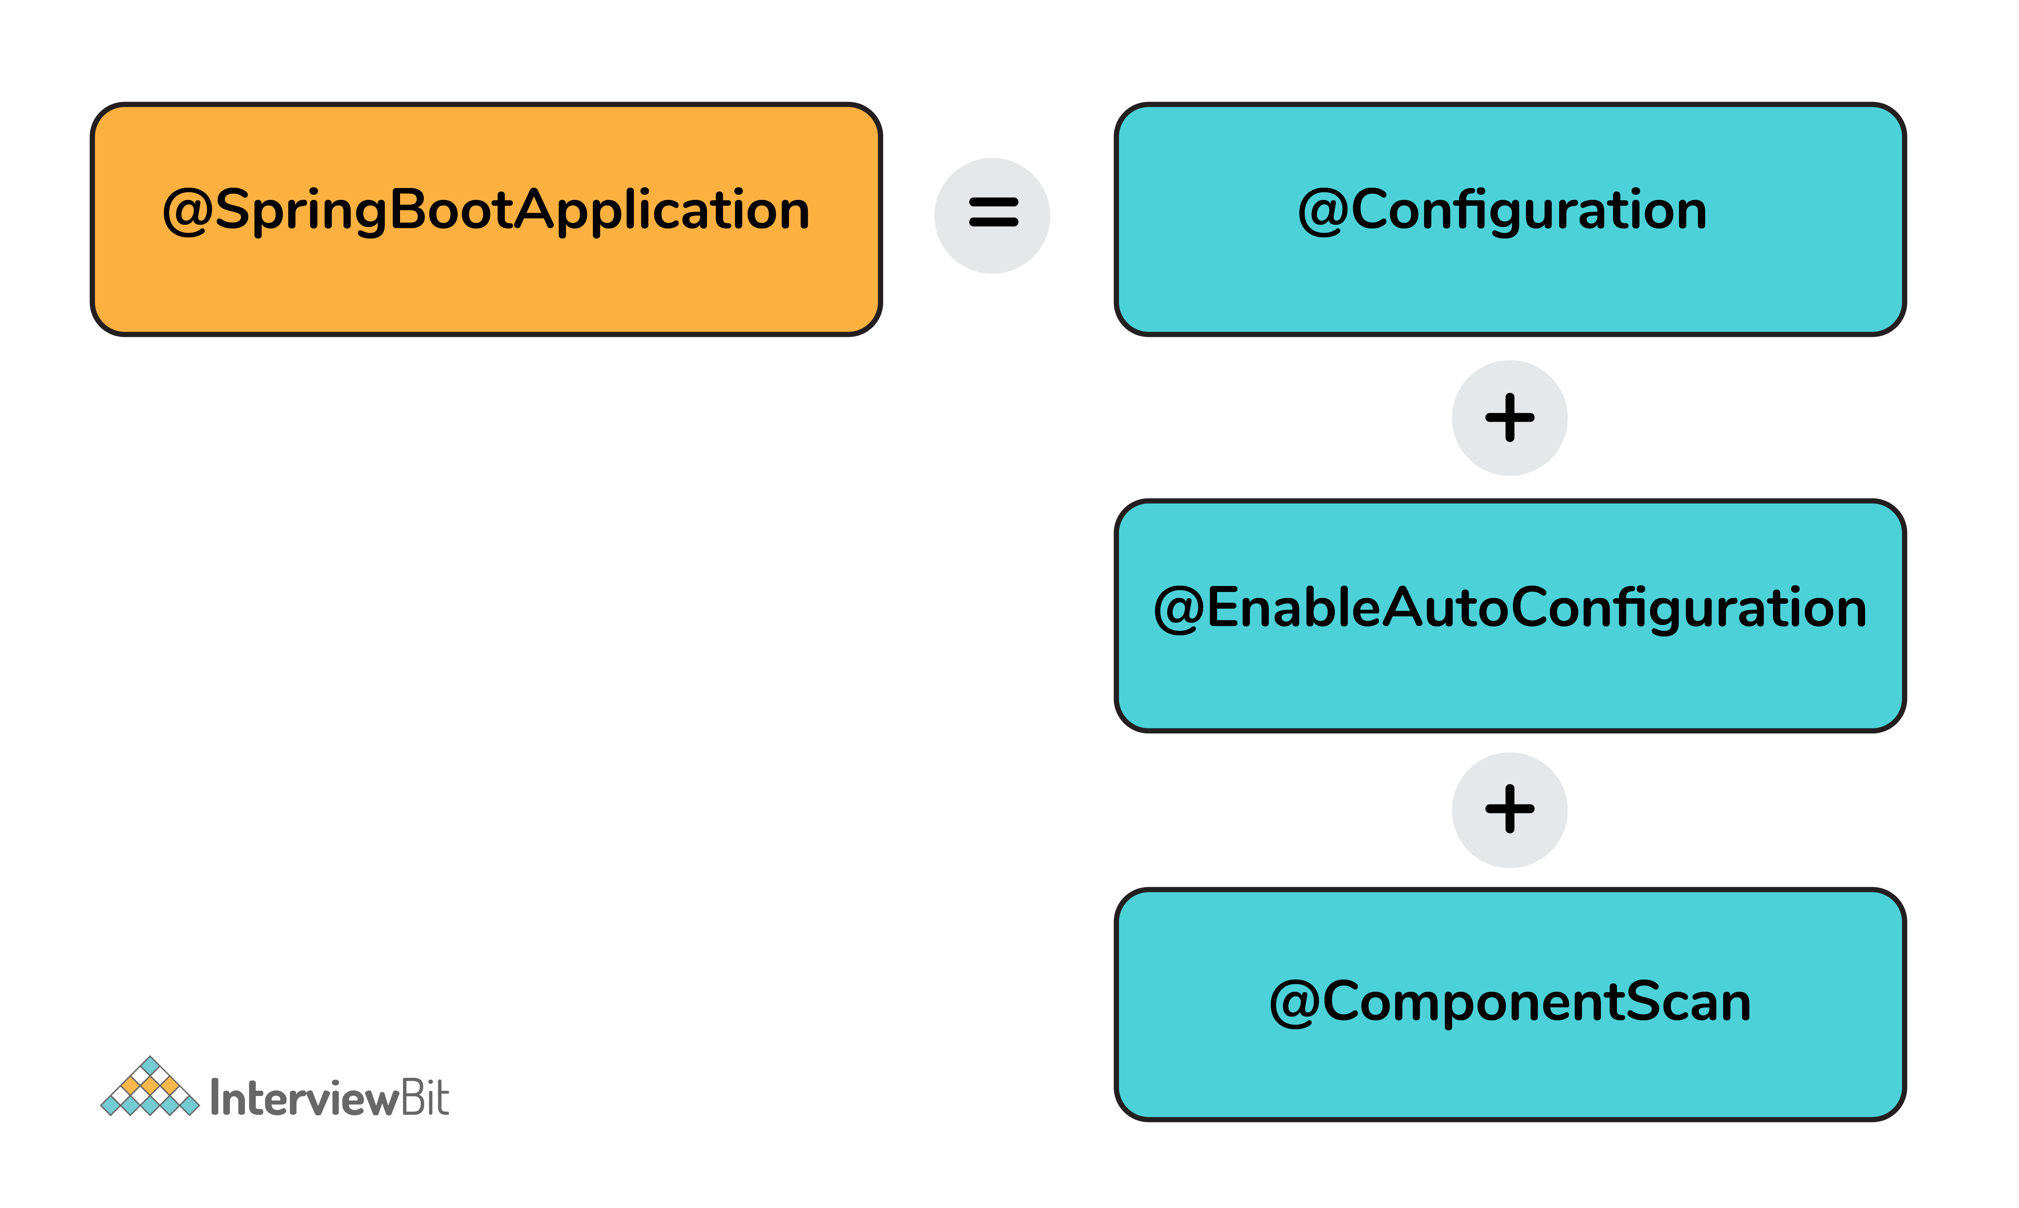
- This enables the developer to use a single annotation instead of using multiple annotations thus lessening the lines of code. However, Spring provides loosely coupled features which is why we can use these annotations as per our project needs.

6. What are the effects of running Spring Boot Application as "Java Application"?
- The application automatically launches the tomcat server as soon as it sees that we are running a web application.

7. What is Spring Boot dependency management system?
- It is basically used to manage dependencies and configuration automatically without the need of specifying the version for any of that dependencies.

8. What are the possible sources of external configuration?
- Spring Boot allows the developers to run the same application in different environments by making use of its feature of external configuration. This uses environment variables, properties files, command-line arguments, YAML files, and system properties to mention the required configuration properties for its corresponding environments. Following are the sources of external configuration:
  - Command-line properties – Spring Boot provides support for command-line arguments and converts these arguments to properties and then adds them to the set of environment properties.
  - Application Properties – By default, Spring Boot searches for the application properties file or its YAML file in the current directory of the application, classpath root or config directory to load the properties.
  - Profile-specific properties – Properties are loaded from the application-{profile}.properties file or its YAML file. This file resides in the same location as that of the non-specific property files and the {profile} placeholder refers to an active profile or an environment.

9. Can we change the default port of the embedded Tomcat server in Spring boot?
- Yes, we can change it by using the application properties file by adding a property of server.port and assigning it to any port you wish to.
- For example, if you want the port to be 8081, then you have to mention server.port=8081. Once the port number is mentioned, the application properties file will be automatically loaded by Spring Boot and the specified configurations will be applied on to the application.

10. Can you tell how to exclude any package without using the basePackages filter?
- We can use the exclude attribute while using the annotation @SpringBootApplication as follows
- @SpringBootApplication(exclude= {Student.class})
- public class InterviewBitAppConfiguration {}

11. How to disable specific auto-configuration class?
- You can use the exclude attribute of @EnableAutoConfiguration for this purpose as shown below:
- @EnableAutoConfiguration(exclude = {InterviewBitAutoConfiguration.class})
If the class is not specified on the classpath, we can specify the fully qualified name as value for the excludeName.
//By using "excludeName"
@EnableAutoConfiguration(excludeName={Foo.class})
- You can add into the application.properties and multiple classes can be added by keeping it comma separated.

12. Can the default web server in the Spring Boot application be disabled?
Yes! application.properties is used to configure the web application type, by mentioning spring.main.web-application-type=none.

13. What are the uses of @RequestMapping and @RestController annotations in Spring Boot?
- @RequestMapping:
  - This provides the routing information and informs Spring that any HTTP request matching the URL must be mapped to the respective method.
  - org.springframework.web.bind.annotation.RequestMapping has to be imported to use this annotation.
- @RestController:
  - This is applied to a class to mark it as a request handler thereby creating RESTful web services using Spring MVC. This annotation adds the @ResponseBody and @Controller annotation to the class.
  - org.springframework.web.bind.annotation.RestController has to be imported to use this annotation.

Spring MVC

1. What is the Spring MVC framework?
- Spring MVC is request driven framework and one of the core components of the Spring framework.
- It comes with ready to use loosely coupled components and elements that greatly aids developers in building flexible and robust web applications.
- The MVC (Model - View - Controller) architecture separates and provides loose coupling between the different aspects of the application – input logic (Model), business logic (Controller), and UI logic (View).

2. What are the benefits of Spring MVC framework over other MVC frameworks?
- Clear separation of roles – There is a specialised dedicated object for every role.
- Reusable business code logic – With Spring MVC, there is no need for duplicating the code. Existing objects can be used as commands instead of replicating them in order to extend a particular framework base class.
- Spring MVC framework provides customizable binding and validation.
- Also provides customizable locale and theme resolution.
- Spring MVC supports customizable handler mapping and view resolution too.

3. What is DispatcherServlet in Spring MVC?
- Spring MVC framework is built around a central servlet called DispatcherServlet that handles all the HTTP requests and responses. The DispatcherServlet does a lot more than that:
  - It seamlessly integrates with the IoC container and allows you to use each feature of Spring in a easier manner.
  - The DispatcherServlet contacts HandlerMapping to call the appropriate Controller for processing the request on receiving it. Then, the controller calls appropriate service methods to set or process the Model data. The service processes the data and returns the view name to DispatcherServlet. DispatcherServlet then takes help of ViewResolver and picks up the defined view for the request. Once the view is decided, the DispatcherServlet passes the Model data to View where it is finally rendered on the browser.
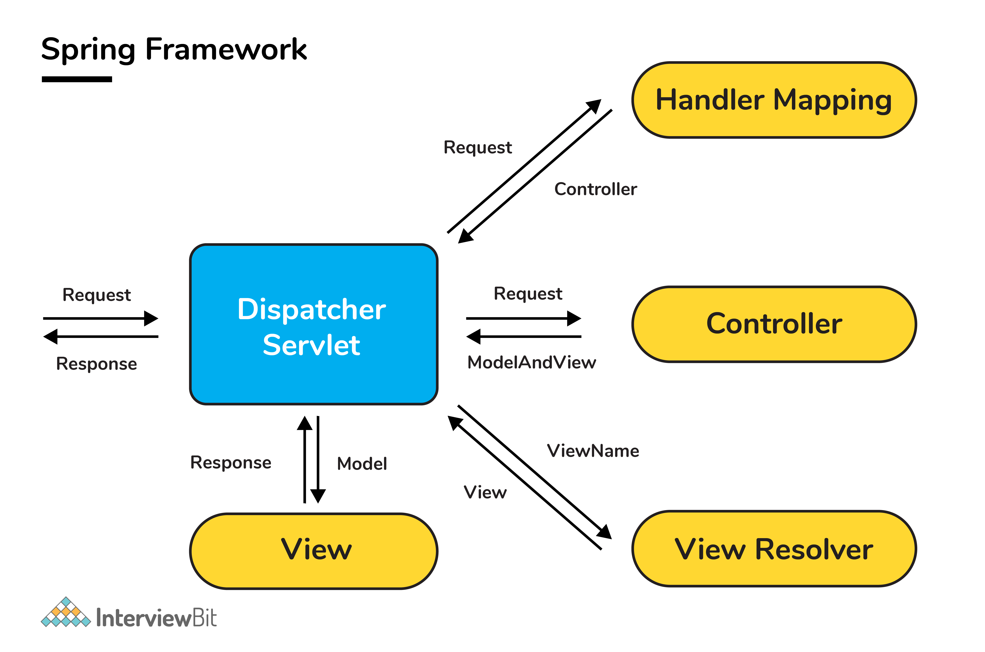

4. What is a View Resolver pattern and explain its significance in Spring MVC?
- It is a J2EE pattern which allows the applications to dynamically choose technology for rendering the data on the browser (View).
  - Any technology like HTML, JSP, XSLT, JSF, or any other such technology can be used as View.
- The View Resolver has the information of different views. The Controller returns the name of the View which is then passed to View Resolver by the DispatcherServlet for selecting the appropriate View technology and then the data is displayed.
- The default ViewResolver used in Spring MVC is InternalResourceViewResolver.

5. How is Validation supported in Spring MVC?
- Spring primarily supports two types of validations:
  - By using JSR-303 Annotations and any reference implementation, for example, Hibernate Validator.
  - Implementing org.springframework.validation.Validator interface and developing customizable validations.

6. What is the @Controller annotation used for?
- The @Controller is a stereotype Spring MVC annotation to define a Controller.

7. Can you create a controller without using @Controller or @RestController annotations?
- Yes! You can create a controller without @Controller or @RestController annotations by annotating the Spring MVC Controller classes using the @Component annotation. In this case, the real job of request mapping to handler method is done using the @RequestMapping annotation.

8. What is ContextLoaderListener and what does it do?
- The ContextLoaderListener loads and creates the ApplicationContext, so a developer need not write explicit code to do create it. In short, it is a listener that aids to bootstrap Spring MVC.
  - The application context is where Spring bean resides. For a web application, there is a subclass called WebAppliationContext.
- The lifecycle of the ApplicationContext is tied to the lifecycle of the ServletContext by using ContextLoaderListener. The ServletContext from the WebApplicationContext can be obtained using the getServletContext() method.

9. What are the differences between @RequestParam and @PathVariable annotations?
- Even though both these annotations are used to extract some data from URL, there is a key difference between them.
  - The @RequestParam is used to extract query parameters that is anything after "?" in the URL.
  - The @PathVariable is used to extract the data present as part of the URI itself.
  - Example, if the given URL is http://localhost:8080/InterviewBit/Spring/SpringMVC/?format=json, then you can access the query parameter "format" using the @RequestParam annotation and /Spring/{type} using the @PathVariable, which will give you SpringMVC.
  - @RequestMapping("/Spring/{type}")
  - public void getQuestions(@PathVariable("type") String type,
  - @RequestParam(value = "format", required = false) String format){
  - /* Some code */
  - }

10. What is the Model in Spring MVC?
- Model is a reference to have the data for rendering.
- It is always created and passed to the view in Spring MVC. If a mapped controller method has Model as parameter, then that model instance is automatically injected to that method.
- Any attributes set on the injected model would be preserved and passed to the View.

Spring AOP, Spring JDBC & Spring Hibernate

1. What is Spring AOP?
- Spring AOP (Aspect Oriented Programming) is similar to OOPs (Object Oriented Programming) as it also provides modularity.
- In AOP key unit is aspects or concerns which are nothing but stand-alone modules in the application. Some aspects have centralized code but other aspects may be scattered or tangled code like in the case of logging or transactions. These scattered aspects are called cross-cutting concern.
  - A cross-cutting concern such as transaction management, authentication, logging, security etc is a concern that could affect the whole application and should be centralized in one location in code as much as possible for security and modularity purposes.
- AOP provides platform to dynamically add these cross-cutting concerns before, after or around the actual logic by using simple pluggable configurations.
- This results in easy maintainenance of code. Concerns can be added or removed simply by modifying configuration files and therefore without the need for recompiling complete sourcecode.
- There are 2 types of implementing Spring AOP:
  - Using XML configuration files
  - Using AspectJ annotation style

2. What is an advice? Explain its types in spring.
- An advice is the implementation of cross-cutting concern can be applied on other modules of the spring application. Advices are of mainly 5 types :
  - Before :
    - This advice executes before a join point, but it does not have the ability to prevent execution flow proceeding to the join point (unless it throws an exception).
    - To use this, use @Before annotation.
  - AfterReturning :
    - This advice is to be executed after a join point completes normally i.e if a method returns without throwing an exception.
    - To use this, use @AfterReturning annotation.
  - AfterThrowing :
    - This advice is to be executed if a method exits by throwing an exception.
    - To use this, use @AfterThrowing annotation.
  - After :
    - This advice is to be executed regardless of the means by which a join point exits (normal return or exception encounter).
    - To use this, use @After annotation.
  - Around :
    - This is the most powerful advice surrounds a join point such as a method invocation.
    - To use this, use @Around annotation.

3. What is Spring AOP Proxy pattern?
- A proxy pattern is a well-used design pattern where a proxy is an object that looks like another object but adds special functionality to it behind the scenes.
- Spring AOP follows proxy-based pattern and this is created by the AOP framework to implement the aspect contracts in runtime.
- The standard JDK dynamic proxies are default AOP proxies that enables any interface(s) to be proxied. Spring AOP can also use CGLIB proxies that are required to proxy classes, rather than interfaces. In case a business object does not implement an interface, then CGLIB proxies are used by default.

4. What are some of the classes for Spring JDBC API?
- Following are the classes
  - JdbcTemplate
  - SimpleJdbcTemplate
  - NamedParameterJdbcTemplate
  - SimpleJdbcInsert
  - SimpleJdbcCall
- The most commonly used one is JdbcTemplate. This internally uses the JDBC API and has the advantage that we don't need to create connection, statement, start transaction,commit transaction and close connection to execute different queries. All these are handled by JdbcTemplate itself. The developer can focus on executing the query directly.

5. How can you fetch records by Spring JdbcTemplate?
- This can be done by using the query method of JdbcTemplate. There are two interfaces that helps to do this:
  - ResultSetExtractor:
    - It defines only one method extractData that accepts ResultSet instance as a parameter and returns the list.
    - Syntax: public T extractData(ResultSet rs) throws SQLException,DataAccessException;
  - RowMapper:
    - This is a enhanced version of ResultSetExtractor that saves a lot of code.
    - It allows to map a row of the relations with the instance of user-defined class.
    - It iterates the ResultSet internally and adds it into the result collection thereby saving lot of code to fetch records.

What are the important features of Spring 5?
Spring 5 is a major overhaul from Spring 4. Some of the important features are:
- Support for Java 8 and higher versions, so we can use lambda expressions.
- Support for Java EE7 and Servlet 4.0 specs.
- File operations are performed via NIO 2 streams now, a huge improvement if your app does a lot of file handling.
- Introduction of spring-jcl to streamline logging, earlier it was a mess due to no single point for logging purposes.
- Support for Kotlin, Lombok, Reactor 3.1 Flux, and Mono as well as RxJava.
- Spring WebFlux that brings reactive programming to Spring.
- Support for JUnit 5
- Support for providing spring components information through index file “META-INF/spring.components” rather than classpath scanning.
Please go through Spring 5 features to get a detailed overview of this release.

5. What is Spring WebFlux?
Spring WebFlux is the new module introduced in Spring 5. Spring WebFlux is the first step towards the reactive programming model in the spring framework.
Spring WebFlux is the alternative to the Spring MVC module. Spring WebFlux is used to create a fully asynchronous and non-blocking application built on the event-loop execution model.
You can read more about it at

What do you understand by Aspect-Oriented Programming?
Enterprise applications have some common cross-cutting concerns that are applicable to different types of Objects and application modules, such as logging, transaction management, data validation, authentication, etc. The modularity of application is achieved by classes in Object-oriented programming. In AOP, application modularity is achieved by Aspects and they are configured to cut across different class methods.
AOP takes out the direct dependency of cross-cutting tasks from classes that are not possible in normal object-oriented programming. For example, we can have a separate class for logging but the other classes will have to call these methods. But, in AOP we configure the aspects and method execution happens automatically. Read more about Spring AOP support at Spring AOP Example.

11. What is Aspect, Advice, Pointcut, JointPoint and Advice Arguments in AOP?
Aspect: Aspect is a class that implements cross-cutting concerns, such as transaction management. Aspects can be a normal class configured and then configured in the Spring Bean configuration file or we can use Spring AspectJ support to declare a class as an Aspect using @Aspect annotation.
Advice: Advice is the action taken for a particular join point. In terms of programming, they are methods that get executed when a specific join point with a matching pointcut is reached in the application. You can think of Advice as Spring interceptors or Servlet Filters.
Pointcut: Pointcuts are regular expressions that are matched with join points to determine whether advice needs to be executed or not. Pointcut uses different kinds of expressions that are matched with the join points. Spring framework uses the AspectJ pointcut expression language for determining the join points where advice methods will be applied.
JoinPoint: A join point is a specific point in the application such as method execution, exception handling, changing object variable values, etc. In Spring AOP a join point is always the execution of a method.
Advice Arguments: We can pass arguments in the advice methods. We can use the args() expression in the pointcut to be applied to any method that matches the argument pattern. If we use this, then we need to use the same name in the advice method from where the argument type is determined.
These concepts seem confusing at first, but if you go through Spring Aspect, Advice Example then you can easily relate to them.

What is the Spring Bean’s life cycle?
Spring Beans are initialized by Spring Container and all the dependencies are also injected. When the context is destroyed, it also destroys all the initialized beans. This works well in most cases but sometimes we want to initialize other resources or do some validation before making our beans ready to use. Spring framework provides support for post-initialization and pre-destroy methods in spring beans.
We can do this in two ways – by implementing InitializingBean and DisposableBean interfaces or using init-method and destroy-method attribute in spring bean configurations. For more details, please read Spring Bean Life Cycle Methods.
Spring Bean Lifecycle: Using Spring Aware Interfaces
When a bean implements an Aware interface, the Spring Framework injects a particular framework object to the bean through a callback-style method. The object Spring injects depends on the interface which the bean implements. For example, if the bean implements the ApplicationContextAware interface, Spring will inject an ApplicationContext object into the bean.
In this post, we will learn about the Spring aware interfaces, particularly ApplicationContextAware, BeanFactoryAware, and BeanNameAware interfaces.
In the bean lifecycle, the Spring Framework calls the aware interface methods after populating bean properties and just before pre initialization with BeanPostProcessor.

The ApplicationContextAware Interface
In Spring beans, you might require access to the ApplicationContext. For example, if your bean needs to look up some other beans. Similarly, if your bean needs access to some application file resource in your bean or even publish some application events, you need access to the ApplicationContext.
Spring provides an ApplicationContextAware interface that allows beans access to the ApplicationContext. This interface provides a single setApplicationContext method.
1
void setApplicationContext(ApplicationContext applicationContext)
2
throws BeansException

The following code shows the use of ApplicationContextAware.
1
6
public class ApplicationContextAwareImpl implements ApplicationContextAware {
7
@Override
8
public void setApplicationContext(ApplicationContext applicationContext) throws BeansException {
9
User user = (User) applicationContext.getBean("user");
10
System.out.println("User Id: " + user.getUserId() + " User Name :" + user.getName());
11
}
12
}
The preceding code is of a bean that implements ApplicationContextAware. The code overrides the setApplicationContext() method to lookup another bean with the id user using the injected ApplicationContext.

The BeanFactoryAware Interface
Beans might need access to the bean factory that created it, say to call any service from the bean factory.
Should you need to obtain a reference to the bean factory, implement the BeanFactoryAware interface. This interface provides the setBeanFactory() method.
1
void setBeanFactory(BeanFactory beanFactory)
The preceding setBeanFactory() is a callback that supplies the owning factory to the bean instance.
Here is an example of a bean that implements the BeanFactoryAware Interface.
public class BeanFactoryAwareImpl implements BeanFactoryAware {
6
@Override
7
public void setBeanFactory(BeanFactory beanFactory) throws BeansException {
8
System.out.println(beanFactory.getBean("user"));
9
}
10
}

The BeanNameAware Interface
The BeanNameAware interface is implemented by beans that need access to its name defined in the Spring container. This interface provides the setBeanName() method.
1
public void setBeanName(String beanName)
Here is an example of a bean which implements the BeanNameAware Interface.
5
public class BeanFactoryAwareImpl implements implements BeanNameAware {
@Override
public void setBeanName(String beanName)
{ System.out.println(beanName);

}
}

The difference between Spring's BeanFactoryPostProcessor and BeanPostProcessor
The user can process the bean of the initialization process by implementing two interfaces: BeanFactoryPostProcessor and BeanPostProcessor.

First, BeanFactoryPostProcessor
The interface source code is as follows:
public interface BeanFactoryPostProcessor {
/ / Can get the bean definition information through the beanFactory
void postProcessBeanFactory(ConfigurableListableBeanFactory beanFactory) throws BeansException; }
The BeanFactoryPostProcessor interface is for the bean container. Its implementation class can modify the bean's definition property before the bean is instantiated after the current BeanFactory is initialized (the spring container loads the bean definition file) to achieve the effect of instantiating the bean after the effect.
That is, Spring allows BeanFactoryPostProcessor to read configuration metadata before the container instantiates any other beans, and can modify it as needed. For example, you can change the scope of the bean from singleton to prototype. You can also modify the value of the property. You can configure multiple BeanFactoryPostProcessors at the same time and control the execution order of each BeanFactoryPostProcessor by setting the 'order' property.
Spring has some built-in BeanFactoryPostProcessor interface implementation classes, as shown below:

Second, BeanPostProcessor
The source code for this method is as follows:
public interface BeanPostProcessor {

//before calling before bean initialization
@Nullable
default Object postProcessBeforeInitialization(Object bean, String beanName) throws BeansException {
return bean;
}
//before calling after bean initialization
@Nullable
default Object postProcessAfterInitialization(Object bean, String beanName) throws BeansException {
return bean;
}
}
BeanPostProcessor can add some processing logic before and after executing the bean initialization method after the spring container instantiates the bean. The initialization method includes the following two types:
1, the bean that implements the InitializingBean interface, the corresponding method is afterPropertiesSet
2, xml definition, the method set by init-method
BeanPostProcessor is executed after BeanFactoryPostProcessor.
Spring has some built-in BeanPostProcessor interface implementation classes, as shown below:
The main difference is: BeanFactoryPostProcessor can modify the BEAN configuration information and BeanPostProcessor cannot, and give an example of an example Bean class: [java] view plain copy...

How to get ServletContext and ServletConfig object in a Spring Bean?
There are two ways to get Container specific objects in the spring bean.
- Implementing Spring *Aware interfaces, for these ServletContextAware and ServletConfigAware interfaces, for a complete example of these aware interfaces, please read Spring Aware Interfaces.
- Using @Autowired annotation with bean variable of type ServletContext and ServletConfig. They will work only in servlet container-specific environments only.
@Autowired
ServletContext servletContext;

- autowiring by @Autowired and @Qualifier annotations

Does Spring Bean provide thread safety?
The default scope of Spring bean is singleton, so there will be only one instance per context. That means that all the having a class level variable that any thread can update will lead to inconsistent data. Hence in default mode spring beans are not thread-safe.
However, we can change spring bean scope to request, prototype or session to achieve thread-safety at the cost of performance. It’s a design decision and based on the project requirements.

What’s the difference between @Component, @Controller, @Repository & @Service annotations in Spring?
@Component is used to indicate that a class is a component. These classes are used for auto-detection and configured as a bean when annotation-based configurations are used.
@Controller is a specific type of component, used in MVC applications and mostly used with RequestMapping annotation.
@Repository annotation is used to indicate that a component is used as a repository and a mechanism to store/retrieve/search data. We can apply this annotation with DAO pattern implementation classes.
@Service is used to indicate that a class is a Service. Usually, the business facade classes that provide some services are annotated with this.
We can use any of the above annotations for a class for auto-detection but different types are provided so that you can easily distinguish the purpose of the annotated classes.

25. What is DispatcherServlet and ContextLoaderListener?
DispatcherServlet is the front controller in the Spring MVC application and it loads the spring bean configuration file and initializes all the beans that are configured. If annotations are enabled, it also scans the packages and configures any bean annotated with @Component, @Controller, @Repository, or @Service annotations.
ContextLoaderListener is the listener to start up and shut down Spring’s root WebApplicationContext. Its important functions are to tie up the lifecycle of ApplicationContext to the lifecycle of the ServletContext and to automate the creation of ApplicationContext. We can use it to define shared beans that can be used across different spring contexts.
<!-- Resolves views selected for rendering by @Controllers to .jsp resources in the /WEB-INF/views directory -->
<beans:bean class="org.springframework.web.servlet.view.InternalResourceViewResolver">
<beans:property name="prefix" value="/WEB-INF/views/" />
<beans:property name="suffix" value=".jsp" />
</beans:bean>

How to handle exceptions in Spring MVC Framework?
Spring MVC Framework provides the following ways to help us achieving robust exception handling.
@ControllerAdvice
31
public class ExceptionHelper {
32
33
private static final Logger logger = LoggerFactory.getLogger(ExceptionHelper.class);
34

35
@ExceptionHandler(value = { InvalidInputException.class })
36
public ResponseEntity<Object> handleInvalidInputException(InvalidInputException ex) {
37
LOGGER.error("Invalid Input Exception: ",ex.getMessage());
38
return new ResponseEntity<Object>(ex.getMessage(),HttpStatus.BAD_REQUEST);
39
}
40

41
@ExceptionHandler(value = { Unauthorized.class })
42
public ResponseEntity<Object> handleUnauthorizedException(Unauthorized ex) {
43
LOGGER.error("Unauthorized Exception: ",ex.getMessage());
44
return new ResponseEntity<Object>(ex.getMessage(),HttpStatus.BAD_REQUEST);
45
}
46

47
@ExceptionHandler(value = { BusinessException.class })
48
public ResponseEntity<Object> handleBusinessException(BusinessException ex) {
49
LOGGER.error("Business Exception: ",ex.getMessage());
50
return new ResponseEntity<Object>(ex.getMessage(),HttpStatus.INTERNAL_SERVER_ERROR);
51
}
52

53
@ExceptionHandler(value = { Exception.class })
54
public ResponseEntity<Object> handleException(Exception ex) {
55
LOGGER.error("Exception: ",ex.getMessage());
56
return new ResponseEntity<Object>(ex.getMessage(),HttpStatus.INTERNAL_SERVER_ERROR);
57
}
58
}

Controller-Based – We can define exception handler methods in our controller classes. All we need is to annotate these methods with @ExceptionHandler annotation.
Global Exception Handler – Exception Handling is a cross-cutting concern and Spring provides @ControllerAdvice annotation that we can use with any class to define our global exception handler.
HandlerExceptionResolver implementation – For generic exceptions, most of the time we serve static pages. Spring Framework provides a HandlerExceptionResolver interface that we can implement to create a global exception handler. The reason behind this additional way to define the global exception handler is that the Spring framework also provides default implementation classes that we can define in our spring bean configuration file to get spring framework exception handling benefits.
For a complete example, please read Spring Exception Handling Example.

29. How to create ApplicationContext in a Java Program?
There are following ways to create spring context in a standalone java program.
- AnnotationConfigApplicationContext: If we are using Spring in standalone Java applications and using annotations for Configuration, then we can use this to initialize the container and get the bean objects.
- ClassPathXmlApplicationContext: If we have a spring bean configuration XML file in a standalone application, then we can use this class to load the file and get the container object.
- FileSystemXmlApplicationContext: This is similar to ClassPathXmlApplicationContext except that the XML configuration file can be loaded from anywhere in the file system.

Can we have multiple Spring configuration files?
For Spring MVC applications, we can define multiple spring context configuration files through contextConfigLocation. This location string can consist of multiple locations separated by any number of commas and spaces. For example;
<servlet>
<servlet-name>appServlet</servlet-name>
<servlet-class>org.springframework.web.servlet.DispatcherServlet</servlet-class>
<init-param>
<param-name>contextConfigLocation</param-name>
<param-value>/WEB-INF/spring/appServlet/servlet-context.xml,/WEB-INF/spring/appServlet/servlet-jdbc.xml</param-value>
</init-param>
<load-on-startup>1</load-on-startup>
</servlet>
We can also define multiple root level spring configurations and load it through context-param. For example;
<context-param>
<param-name>contextConfigLocation</param-name>
<param-value>/WEB-INF/spring/root-context.xml /WEB-INF/spring/root-security.xml</param-value>
</context-param>
Another option is to use import element in the context configuration file to import other configurations, for example:
<beans:import resource="spring-jdbc.xml"/>
ContextLoaderListener is the listener class used to load root context and define spring bean configurations that will be visible to all other contexts. It’s configured in web.xml file as:
<context-param>
<param-name>contextConfigLocation</param-name>
<param-value>/WEB-INF/spring/root-context.xml</param-value>
</context-param>

<listener>
<listener-class>org.springframework.web.context.ContextLoaderListener</listener-class>
</listener>

What are some of the important Spring annotations you have used?
Some of the Spring annotations that I have used in my project are:
- @Controller – for controller classes in Spring MVC project.
- @RequestMapping – for configuring URI mapping in controller handler methods. This is a very important annotation, so you should go through Spring MVC RequestMapping Annotation Examples
- @ResponseBody – for sending Object as a response, usually for sending XML or JSON data as a response.
- @PathVariable – for mapping dynamic values from the URI to handler method arguments.
- @Autowired – for auto wiring dependencies in spring beans.
- @Qualifier – with @Autowired annotation to avoid confusion when multiple instances of bean type are present.
- @Service – for service classes.
- @Scope – for configuring scope of the spring bean.
- @Configuration, @ComponentScan, and @Bean – for java based configurations.
- AspectJ annotations for configuring aspects and advice, @Aspect, @Before, @After, @Around, @Pointcut, etc.

What is Spring MVC Interceptor and how to use it?
Spring MVC Interceptors are like Servlet Filters and allow us to intercept client requests and process them. We can intercept client requests at three places – preHandle, postHandle, and afterCompletion.
We can create a spring interceptor by implementing the HandlerInterceptor interface or by extending the abstract class HandlerInterceptorAdapter.
We need to configure interceptors in the spring bean configuration file. We can define an interceptor to intercept all the client requests or we can configure it for specific URI mapping too. For a detailed example, please refer Spring MVC Interceptor Example.

How would you achieve Transaction Management in Spring?
Spring framework provides transaction management support through Declarative Transaction Management as well as programmatic transaction management. Declarative transaction management is most widely used because it’s easy to use and works in most of the cases.
We use annotate a method with @Transactional annotation for Declarative transaction management. We need to configure the transaction manager for the DataSource in the spring bean configuration file.
<bean id="transactionManager"
class="org.springframework.jdbc.datasource.DataSourceTransactionManager">
<property name="dataSource" ref="dataSource" />
</bean>

How to inject a java.util.Properties into a Spring Bean?
We have to define the propertyConfigurer bean that will load the properties from the given property file. Then we can use Spring EL support to inject properties into other bean dependencies. For example:
<bean id="propertyConfigurer"
class="org.springframework.context.support.PropertySourcesPlaceholderConfigurer">
<property name="location" value="/WEB-INF/application.properties" />
</bean>

<bean class="com.journaldev.spring.EmployeeDaoImpl">
<property name="maxReadResults" value="${results.read.max}"/>
</bean>
If you are using annotation to configure the spring bean, then you can inject property like below.
@Value("${maxReadResults}")
private int maxReadResults;

How to integrate spring and hibernate xml based
- <bean id="dataSource" class="org.apache.commons.dbcp.BasicDataSource">
- <property name="driverClassName" value="oracle.jdbc.driver.OracleDriver"></property>
- <property name="url" value="jdbc:oracle:thin:@localhost:1521:xe"></property>
- <property name="username" value="system"></property>
- <property name="password" value="oracle"></property>
- </bean>

- <bean id="mysessionFactory" class="org.springframework.orm.hibernate3.LocalSessionFactoryBean">
- <property name="dataSource" ref="dataSource"></property>

- <property name="mappingResources">
- <list>
- <value>employee.hbm.xml</value>
- </list>
- </property>

- <property name="hibernateProperties">
- <props>
- <prop key="hibernate.dialect">org.hibernate.dialect.Oracle9Dialect</prop>
- <prop key="hibernate.hbm2ddl.auto">update</prop>
- <prop key="hibernate.show_sql">true</prop>

- </props>
- </property>
- </bean>

- <bean id="template" class="org.springframework.orm.hibernate3.HibernateTemplate">
- <property name="sessionFactory" ref="mysessionFactory"></property>
- </bean>

- <bean id="d" class="com.javatpoint.EmployeeDao">
- <property name="template" ref="template"></property>
- </bean>

- </beans>

- public class EmployeeDao {
- HibernateTemplate template;
- public void setTemplate(HibernateTemplate template) {
- this.template = template;
- }
- //method to save employee
- public void saveEmployee(Employee e){
- template.save(e);
- }
}

Now integrate spring with MongoDB

MongoTemplate and MongoRepository
The MongoTemplate follows the standard template pattern in Spring and provides a ready to go, basic API to the underlying persistence engine.
The repository follows the Spring Data-centric approach and comes with more flexible and complex API operations, based on the well-known access patterns in all Spring Data projects.
For both, we need to start by defining the dependency – for example, in the pom.xml, with Maven:
<dependency>
<groupId>org.springframework.data</groupId>
<artifactId>spring-data-mongodb</artifactId>
<version>3.0.3.RELEASE</version>
</dependency>

Configuration for MongoTemplate

3.1. XML Configuration
Let’s start with the simple XML configuration for the Mongo template:
<mongo:mongo-client id="mongoClient" host="localhost" />
<mongo:db-factory id="mongoDbFactory" dbname="test" mongo-client-ref="mongoClient" />
First, we need to define the factory bean responsible for creating Mongo instances.
Next – we need to actually define (and configure) the template bean:
<bean id="mongoTemplate" class="org.springframework.data.mongodb.core.MongoTemplate">
<constructor-arg ref="mongoDbFactory"/>
</bean>
And finally, we need to define a post processor to translate any MongoExceptions thrown in @Repository annotated classes:
<bean class=
"org.springframework.dao.annotation.PersistenceExceptionTranslationPostProcessor"/>

3.2. Java Configuration
Let’s now create a similar configuration using Java config by extending the base class for MongoDB configuration AbstractMongoConfiguration:
@Configuration
public class MongoConfig extends AbstractMongoClientConfiguration {

@Override
protected String getDatabaseName() {
return "test";
}

@Override
public MongoClient mongoClient() {
ConnectionString connectionString = new ConnectionString("mongodb://localhost:27017/test");
MongoClientSettings mongoClientSettings = MongoClientSettings.builder()
.applyConnectionString(connectionString)
.build();

return MongoClients.create(mongoClientSettings);
}

@Override
public Collection getMappingBasePackages() {
return Collections.singleton("com.baeldung");
}
}
Note: We didn't need to define MongoTemplate bean in the previous configuration as it's already defined in AbstractMongoClientConfiguration.
We can also use our configuration from scratch without extending AbstractMongoClientConfiguration – as follows:
@Configuration
public class SimpleMongoConfig {

@Bean
public MongoClient mongo() {
ConnectionString connectionString = new ConnectionString("mongodb://localhost:27017/test");
MongoClientSettings mongoClientSettings = MongoClientSettings.builder()
.applyConnectionString(connectionString)
.build();

return MongoClients.create(mongoClientSettings);
}

@Bean
public MongoTemplate mongoTemplate() throws Exception {
return new MongoTemplate(mongo(), "test");
}
}

4. Configuration for MongoRepository

4.1. XML Configuration
To make use of custom repositories (extending the MongoRepository) – we need to continue the configuration from section 3.1 and set up the repositories:
<mongo:repositories
base-package="com.baeldung.repository" mongo-template-ref="mongoTemplate"/>

4.2. Java Configuration
Similarly, we'll build on the configuration we already created in section 3.2 and add a new annotation into the mix:
@EnableMongoRepositories(basePackages = "com.baeldung.repository")

4.3. Create the Repository
Now, after the configuration, we need to create a repository – extending the existing MongoRepository interface:
public interface UserRepository extends MongoRepository<User, String> {
//
}
Now we can auto-wire this UserRepository and use operations from MongoRepository or add custom operations.

5. Using MongoTemplate

5.1. Insert
Let's start with the insert operation; let's also start with an empty database:
{
}
Now if we insert a new user:
User user = new User();
user.setName("Jon");
mongoTemplate.insert(user, "user");
The database will look like this:
{
"_id" : ObjectId("55b4fda5830b550a8c2ca25a"),
"_class" : "com.baeldung.model.User",
"name" : "Jon"
}

5.2. Save – Insert
The save operation has save-or-update semantics: if an id is present, it performs an update, if not – it does an insert.
Let's look at the first semantic – the insert; here's the initial state of the database:
{
}
When we now save a new user:
User user = new User();
user.setName("Albert");
mongoTemplate.save(user, "user");
The entity will be inserted in the database:
{
"_id" : ObjectId("55b52bb7830b8c9b544b6ad5"),
"_class" : "com.baeldung.model.User",
"name" : "Albert"
}
Next, we'll look at the same operation – save – with update semantics.

5.3. Save – Update
Let's now look at save with update semantics, operating on an existing entity:
{
"_id" : ObjectId("55b52bb7830b8c9b544b6ad5"),
"_class" : "com.baeldung.model.User",
"name" : "Jack"
}
Now, when we save the existing user – we will update it:
user = mongoTemplate.findOne(
Query.query(Criteria.where("name").is("Jack")), User.class);
user.setName("Jim");
mongoTemplate.save(user, "user");

When we now run the updateFirst:
Query query = new Query();
query.addCriteria(Criteria.where("name").is("Alex"));
Update update = new Update();
update.set("name", "James");
mongoTemplate.updateFirst(query, update, User.class);

Now, let's now run the updateMulti operation:
Query query = new Query();
query.addCriteria(Criteria.where("name").is("Eugen"));
Update update = new Update();
update.set("name", "Victor");
mongoTemplate.updateMulti(query, update, User.class);

Let's look at the actual operation code:
Query query = new Query();
query.addCriteria(Criteria.where("name").is("Markus"));
Update update = new Update();
update.set("name", "Nick");
User user = mongoTemplate.findAndModify(query, update, User.class);

Now – let's run the upsert:
Query query = new Query();
query.addCriteria(Criteria.where("name").is("Markus"));
Update update = new Update();
update.set("name", "Nick");
mongoTemplate.upsert(query, update, User.class);

Let's now run remove:
mongoTemplate.remove(user, "user");

Using MongoRepository

6.1. Insert
First – the state of the database before running the insert:
{
}
Now, when we insert a new user:
User user = new User();
user.setName("Jon");
userRepository.insert(user);
Here's the end state of the database:
{
"_id" : ObjectId("55b4fda5830b550a8c2ca25a"),
"_class" : "com.baeldung.model.User",
"name" : "Jon"
}
Note how the operation works the same as the insert in the MongoTemplate API.

6.2. Save – Insert
Similarly – save works the same as the save operation in the MongoTemplate API.
Let's start by looking at the insert semantics of the operation; here's the initial state of the database:
{
}
Now – we execute the save operation:
User user = new User();
user.setName("Aaron");
userRepository.save(user);
This results in the user being added to the database:
{
"_id" : ObjectId("55b52bb7830b8c9b544b6ad5"),
"_class" : "com.baeldung.model.User",
"name" : "Aaron"
}
Note again how, in this example, save works with insert semantics, because we are inserting a new object.

6.3. Save – Update
Let's now look at the same operation but with update semantics.
First – here's the state of the database before running the new save:
{
"_id" : ObjectId("55b52bb7830b8c9b544b6ad5"),
"_class" : "com.baeldung.model.User",
"name" : "Jack"81*6
}
Now – we execute the operation:
user = mongoTemplate.findOne(
Query.query(Criteria.where("name").is("Jack")), User.class);
user.setName("Jim");
userRepository.save(user);
Finally, here is the state of the database:
{
"_id" : ObjectId("55b52bb7830b8c9b544b6ad5"),
"_class" : "com.baeldung.model.User",
"name" : "Jim"
}
Note again how, in this example, save works with update semantics, because we are using an existing object.

6.4. Delete
The state of the database before calling delete:
{
"_id" : ObjectId("55b5ffa5511fee0e45ed614b"),
"_class" : "com.baeldung.model.User",
"name" : "Benn"
}
Let's run delete:
userRepository.delete(user);
The result will simply be:
{
}

6.5. FindOne
The state of the database when findOne is called:
{
"_id" : ObjectId("55b5ffa5511fee0e45ed614b"),
"_class" : "com.baeldung.model.User",
"name" : "Chris"
}
Let's now execute the findOne:
userRepository.findOne(user.getId())
The result which will return the existing data:
{
"_id" : ObjectId("55b5ffa5511fee0e45ed614b"),
"_class" : "com.baeldung.model.User",
"name" : "Chris"
}

Now, let's run exists:
boolean isExists = userRepository.exists(user.getId());

List<User> users = userRepository.findAll(Sort.by(Sort.Direction.ASC, "name"));

Pageable pageableRequest = PageRequest.of(0, 1); Page<User> page = userRepository.findAll(pageableRequest); List<User> users = pages.getContent();

@Document("Employee")
public class Employee {

@Id
private String empId;
private String name;
private int age;
private double salary;

//getters and setters

What are you using PDF generation in spring –
<dependency>
<groupId>com.itextpdf</groupId>
<artifactId>itextpdf</artifactId>
<version>5.5.10</version>

</dependency>

<dependency>
<groupId>org.apache.pdfbox</groupId>
<artifactId>pdfbox</artifactId>
<version>2.0.4</version>
</dependency>

import com.itextpdf.html2pdf.ConverterProperties;
import com.itextpdf.html2pdf.HtmlConverter;
import com.itextpdf.html2pdf.resolver.font.DefaultFontProvider;
import com.itextpdf.io.font.FontProgram;
import com.itextpdf.io.font.FontProgramFactory;
import com.itextpdf.layout.font.FontProvider;
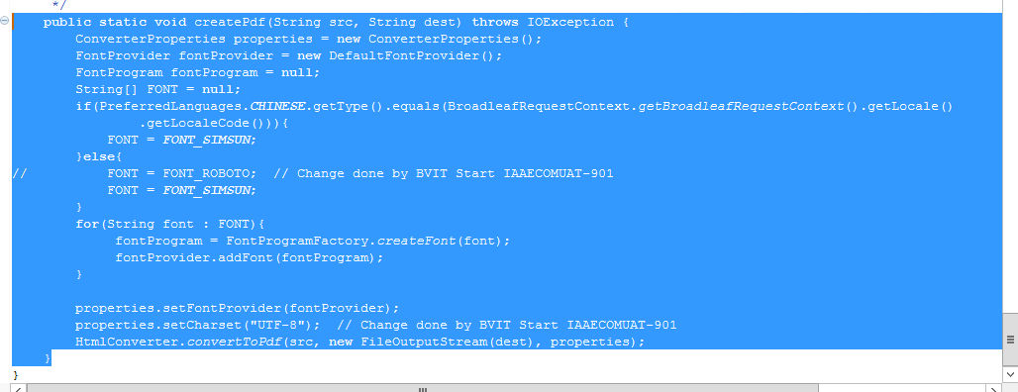

@RequestMapping(value = "/prePaymentInvoiceDownload/{orderName}"+"_PrepaymentInvoice" ,produces = "application/json; charset=UTF-8")
@PreAuthorize("@bvOrderSecurityService.hasPermissionToModifyOrder(#orderName, principal.username)")
//Added @PreAuthorize - protect logged in user to access the order details of other users -khem
public void prePaymentInvoiceGenerate(HttpServletRequest request, HttpServletResponse response, Model model,
@PathVariable("orderName") String orderName ,@RequestParam(name="approve" ,defaultValue="false",required=false) String approve) {
try {
generatePrePaymentInvoice(request,orderName,approve);

} catch (Exception e) {
}
ArrayList<String> paymentPdfPathList = (ArrayList<String>) request.getSession().getAttribute("paymentPdfPathList");
if (null != orderName) {
if (null != paymentPdfPathList && !(paymentPdfPathList.isEmpty())) {
for (String paymentPdfPath : paymentPdfPathList) {
if (null != Paths.get(paymentPdfPath)) {
response.setContentType("application/pdf");
String fileName = Paths.get(paymentPdfPath).getFileName().toString();
if (StringUtils.containsIgnoreCase(fileName, orderName)) {
response.addHeader("Content-Disposition", "inline; filename=" + fileName);
try {
Files.copy(Paths.get(Paths.get(paymentPdfPath).getParent().toString(),fileName), response.getOutputStream());/*Paths.get(paymentPdfPath).getParent().toString(),*/
response.getOutputStream().flush();
} catch (IOException e) {
logger.error("Exception in prePaymentInvoiceGenerate method : " + e.getMessage());
}
try {
Files.deleteIfExists(Paths.get(Paths.get(paymentPdfPath).getParent().toString(),fileName));
} catch (IOException e) {
logger.error("Exception in Deleting the Invoice : "+Paths.get(Paths.get(paymentPdfPath).getParent().toString(),fileName));
logger.error(e.getMessage());
}
}
}
}
}public String createPdf(String templatePath,String templateName, Map<String,Object> map) throws Exception {
logger.info(":::::::createPdf::::"+templatePath);
File outputFile=null;
String delimiter = "/";
String path = MessageConstants.PAYMENT_INVOICE_LOCATION;

Assert.notNull(templateName, "The templateName can not be null");
Context ctx = new Context();
if (map != null) {
Iterator<Entry<String, Object>> itMap = map.entrySet().iterator();
while (itMap.hasNext()) {
Map.Entry pair = (Map.Entry) itMap.next();
ctx.setVariable(pair.getKey().toString(), pair.getValue());
}
}

StringBuffer directory = new StringBuffer();
directory.append(path);
File dir = new File(directory.toString());
FileUtils.forceMkdir(dir);
directory.append(delimiter);
if(PreferredLanguages.CHINESE.getType().equals(BroadleafRequestContext.getBroadleafRequestContext().getLocale().getLocaleCode())){
ctx.setLocale(java.util.Locale.CHINESE);
}
String processedHtml = templateEngine.process(templatePath, ctx);
try {
outputFile = new File(directory + templateName + ".pdf");
while (outputFile.exists() && !outputFile.isDirectory()) {
outputFile = new File(directory + templateName + "(" + count + ")" + ".pdf");
count++;
}
filePath = outputFile.toString();
createPdf(processedHtml, outputFile.toString());
}catch(Exception e){
logger.info("exception in the catch block of pdf generator util class::",e);
}
logger.info(":::::::End createPdf::::"+filePath);
return filePath;
}
}
}

What are you using for reading and creating excel

org.apache.poi.ss.usermodel.Sheet;
import org.apache.poi.ss.usermodel.Workbook;
import org.apache.poi.ss.usermodel.WorkbookFactory;

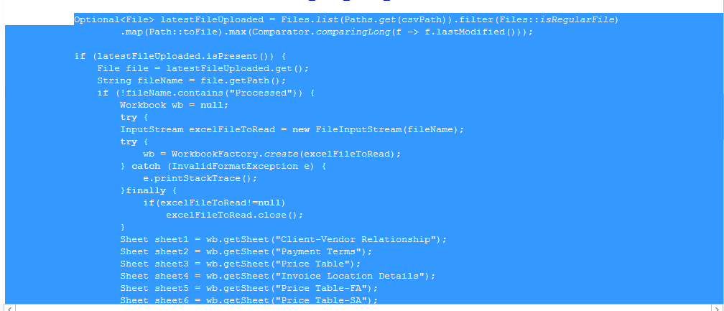
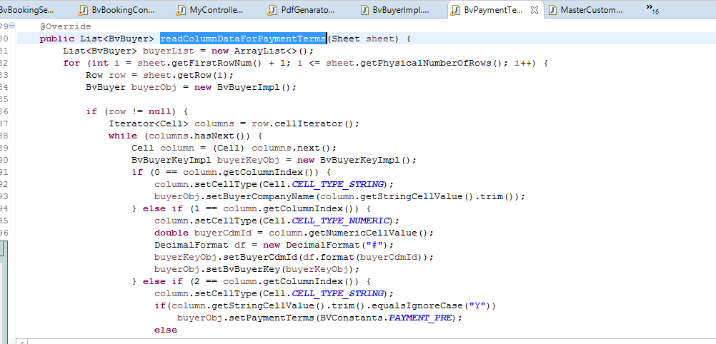
Ask Question

